**LEBANESE AMERICAN UNIVERSITY**

**USAID – HIGHER EDUCATION SCHOLARSHIP PROGRAM**

**HES - Volunteering Program Verification Form**

This form is to be used to document volunteering hours. If a student volunteers for multiple organizations, a separate form must be used for each organization. **This form must be turned in by the 28th of each month, the latest.**

I certify that the scholar Jawad Youness completed a total of 5 hours of service at InnovaThrive.

The hours were completed hours as per the below:

Hours # 0 (date) _2/12 – 6/12_ (initials of supervisor) __A.K.___

Hours # 0 (date) _9/12 – 13/12_ (initials of supervisor) __A.K.___

Hours # 0 date) _16/12 – 20/12 (initials of supervisor) __A.K.___

Hours # 5 date) _23/12 - 27/12 (initials of supervisor) __A.K.___

Brief description of the activities the scholar performed or participated in:

The Role of AI in Combating Global Food Waste  
Definition: Exploring how AI can reduce food waste across production, distribution, and consumption stages.  
Technologies:  
  
  
Predictive analytics for supply chain optimization.  
  
  
AI for tracking expiration dates and surplus inventory.  
  
Applications:  
  
  
Automating redistribution of surplus food to shelters.  
  
  
AI-powered apps for consumers to track food freshness.  
  
Statistics: Reduction in food waste by 30% in AI-optimized supply chains.  
  
Advantages:  
  
  
Cost savings for producers and retailers.  
  
  
Improved food security for underserved populations.  
  
Disadvantages:  
  
  
Limited adoption in low-resource regions.  
  
Challenges:  
  
  
Addressing logistical barriers in food redistribution systems.  
  
Future Research:  
  
  
AI in scaling sustainable food production practices.  
  
  
Enhancing AI’s role in predicting seasonal surpluses

Written feedback about the scholar’s performance:

Jawad Youness’ exploration of AI in combating food waste was well-researched, providing practical applications and demonstrating AI’s role in reducing waste across supply chains.

Please rate the overall performance of the scholar at your organization:

|  |  |  |  |
| --- | --- | --- | --- |
|  | Mastery (5) | Proficient (3) | Emerging (1) |
| **Problem solver** | X |  |  |
| **Engaged & Committed** | X |  |  |
| **Open-minded & multicultural** | X |  |  |

Signature

& stamp

__________________________

_

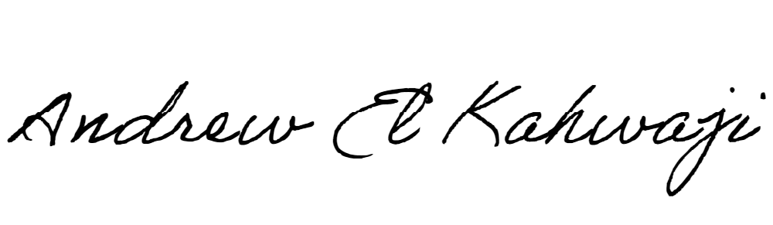

Printed Name _Andrew El Kahwaji_

Date __26/12/2024___

Email __andrew.lifesculptor.coo@gmail.com __

Phone __+961 71 914 378__